Department of Computing
CS: Data Structures and Algorithms
Class: BSAI A

Lab 05
Stacks and Queue
Implementation Using Structures and Classes
CLO 2: Solve a given real-time problem by applying appropriate data structure and algorithm.
CLO 3 – Practice programs using the latest IDEs ensuring testing, documentation and packaging
Date: 7th October 2026
Duration: 3 hours
Instructor: Saud Kamran
Lab Engineer: Hassan Mohtashim

Introduction

Stacks and queues are fundamental linear data structures used to organize and process data according to specific rules. A stack follows the Last-In, First-Out (LIFO) principle, where the most recently inserted element is removed first. A queue follows the First-In, First-Out (FIFO) principle, where the earliest inserted element is processed first.

In this lab, students will implement stacks and queues using linked nodes and apply them to practical problems. Stack-based applications will include expression checking, conversion, and evaluation, while a queue will be used to simulate printer job scheduling.

Students will also practice dynamic memory management, pointer manipulation, error handling, and testing of different edge cases.

Objectives
By the end of this lab, students should be able to:
- Implement a stack using linked nodes.
- Implement a queue using linked nodes.
- Perform basic stack operations such as push, pop, and top.
- Perform basic queue operations such as enqueue and dequeue.
- Apply stacks to expression processing.
- Apply queues to FIFO-based job scheduling.
- Convert and evaluate arithmetic expressions using a stack.
- Handle empty structures and invalid operations.
- Manage dynamically allocated memory correctly.
- Test data structures using normal and edge-case inputs.

Prerequisites
- Students should have an understanding of:
- Structures/classes
- Pointers
- Dynamic memory allocation
- Linked lists
- Functions
- Basic arithmetic expressions
- Conditional statements and loops

Lab Tasks

Guided review 20 minutes; Task 1 – 30 minutes; Task 2 – 35 minutes; Task 3 – 45 minutes; checking and submission – 15 minutes.

Task 1 - Expression Parentheses Checker Using a Stack
Implement a stack using linked nodes and use it to check whether an arithmetic expression contains balanced parentheses, brackets, and braces.
Each stack node should store one character.
The program should support the following operations:
1. Push – Insert a character onto the top of the stack.
2. Pop – Remove the character from the top of the stack.
3. Top – Display/return the character currently at the top.
4. IsEmpty – Check whether the stack contains any elements.
5. Check Balance – Process an expression and determine whether all (), [], and {} are correctly matched.
6. Display Stack – Display the current contents of the stack.
7. Clear Stack – Remove all nodes and release allocated memory.
Implementation Requirements
- Use a linked-node implementation.
- Do not use the STL stack.
- Opening brackets should be pushed onto the stack.
- When a closing bracket is encountered, compare it with the top opening bracket.
- Detect mismatched brackets.
- Detect extra opening or closing brackets.
- Correctly handle an empty expression.
- Correctly handle an expression containing no brackets.
- The stack must be empty after a successfully balanced expression is processed.
- Dynamically allocated nodes must be properly deleted.
Test Cases
Test the program with:
- (A+B)
- {A+[B*C]}
- (A+B]
- ((A+B)
- {[()]}
- A+B*C
- ([A+B])
Display whether each expression is Balanced or Not Balanced.
CODE:
#include <iostream>
#include <string>
using namespace std;

// Nodefor Stack
struct Node
{
char data;
Node* next;
};

// Stack class
class Stack
{
private:
Node* topNode;

public:
Stack()
{
topNode = nullptr;
}

// Push character
void push(char ch)
{
Node* newNode = new Node;
newNode->data = ch;
newNode->next = topNode;
topNode = newNode;
}
// Pop
char pop()
{
if (isEmpty())
{
return '\0';
}
Node* temp = topNode;
char ch = temp->data;
topNode = topNode->next;
delete temp;
return ch;
}
// Return top chatacter
char top()
{
if (isEmpty())
{
return '\0';
}

return topNode->data;
}

// Check stack is enpty
bool isEmpty()
{
return topNode == nullptr;
}

// Display stack
void display()
{
if (isEmpty())
{
cout << "Stack is empty." << endl;
return;
}

Node* current = topNode;
cout << "Stack: ";

while (current != nullptr)
{
cout << current->data << " ";
current = current->next;
}

cout << endl;
}

void clear()
{
while (!isEmpty())
{
pop();
}
}

// Destructor
~Stack()
{
clear();
}
};

// Check brackets match
bool matches(char opening, char closing)
{
if (opening == '(' && closing == ')')
return true;

if (opening == '[' && closing == ']')
return true;

if (opening == '{' && closing == '}')
return true;

return false;
}

//balance of expression
bool checkBalance(string expression)
{
Stack stack;

for (int i = 0; i < expression.length(); i++)
{
char ch = expression[i];

if (ch == '(' || ch == '[' || ch == '{')
{
stack.push(ch);
}
// Closing brackets
else if (ch == ')' || ch == ']' || ch == '}')
{
if (stack.isEmpty())
{
return false;
}

char opening = stack.pop();

if (!matches(opening, ch))
{
return false;
}
}
}

return stack.isEmpty();
}
int main()
{
string tests[] =
{
"(A+B)",
"{A+[B*C]}",
"(A+B]",
"((A+B)",
"{[()]}",
"A+B*C",
"([A+B])"
};

for (int i = 0; i < 7; i++)
{
cout << tests[i] << " : ";

if (checkBalance(tests[i]))
cout << "Balanced" << endl;
else
cout << "Not Balanced" << endl;
}

return 0;
}

OUTPUT:
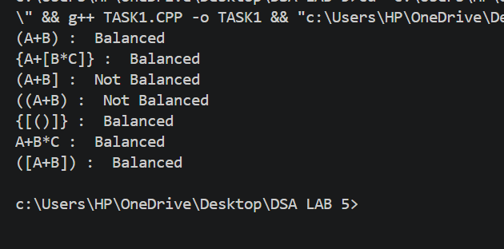

Task 2 - Printer Job Scheduling Using a Queue
Implement a queue using linked nodes to simulate a printer processing print jobs in First-In-First-Out (FIFO) order.
Each queue node should store:
- Job ID
- Document Name
- Number of Pages
Maintain both front and rear pointers.
The program should support the following operations:
- Add Job – Insert a new print job at the rear of the queue.
- Process Job – Remove and process the job at the front.
- View Next Job – Display the job currently at the front without removing it.
- Display Queue – Display all waiting jobs from front to rear.
- Count Jobs – Display the number of jobs currently waiting.
- IsEmpty – Check whether the queue is empty.
- Clear Queue – Remove all jobs and release allocated memory.
Implementation Requirements
- Use a linked-node implementation.
- Do not use the STL queue.
- New jobs must always enter from the rear.
- Jobs must always be processed from the front.
- Maintain correct front and rear pointers after every insertion and deletion.
- Correctly handle an empty queue.
- Correctly handle a queue containing only one job.
- When the last job is removed, both front and rear must become empty.
- Dynamically allocated nodes must be properly deleted.

CODE:

#include <iostream>
#include <string>
using namespace std;

struct Job {
int id, pages;
string document;
Job* next;
};

class Queue {
Job* front;
Job* rear;
int count;

public:
Queue() {
front = rear = NULL;
count = 0;
}

bool isEmpty() {
return front == NULL;
}

void addJob(int id, string doc, int pages) {
Job* newJob = new Job{id, pages, doc, NULL};

if (isEmpty())
front = rear = newJob;
else {
rear->next = newJob;
rear = newJob;
}

count++;
cout << "Job added: " << id << endl;
}

void processJob() {
if (isEmpty()) {
cout << "Queue is empty. No job to process.\n";
return;
}

Job* temp = front;
cout << "Processing: " << temp->id << " "
<< temp->document << " (" << temp->pages
<< " pages)\n";

front = front->next;
delete temp;
count--;

if (front == NULL)
rear = NULL;
}

void viewNextJob() {
if (isEmpty()) {
cout << "No jobs waiting.\n";
return;
}

cout << "Next job: " << front->id << " "
<< front->document << ", "
<< front->pages << " pages\n";
}

void displayQueue() {
if (isEmpty()) {
cout << "Queue is empty.\n";
return;
}

Job* temp = front;
while (temp != NULL) {
cout << temp->id << " | " << temp->document
<< " | " << temp->pages << " pages\n";
temp = temp->next;
}
}

void countJobs() {
cout << "Waiting jobs: " << count << endl;
}

void clearQueue() {
while (!isEmpty()) {
Job* temp = front;
front = front->next;
delete temp;
}

rear = NULL;
count = 0;
cout << "Queue cleared.\n";
}

~Queue() {
clearQueue();
}
};

int main() {
Queue q;

q.addJob(101, "Assignment1.pdf", 10);
q.addJob(102, "Report.docx", 25);
q.addJob(103, "Notes.pdf", 5);
q.addJob(104, "LabTask.docx", 15);

cout << "\nAll jobs:\n";
q.displayQueue();

cout << "\nProcess two jobs:\n";
q.processJob();
q.processJob();

cout << "\nRemaining jobs:\n";
q.displayQueue();

cout << "\nAdd a new job:\n";
q.addJob(105, "Project.pdf", 20);

q.viewNextJob();
q.countJobs();

cout << "\nProcess all remaining jobs:\n";
while (!q.isEmpty())
q.processJob();

cout << "\nTry processing an empty queue:\n";
q.processJob();

q.clearQueue();
return 0;
}

Test Case
Add the following jobs:
Job ID | Document | Pages
101 | Assignment1.pdf | 10
102 | Report.docx | 25
103 | Notes.pdf | 5
104 | LabTask.docx | 15
Then:
- Display all jobs.
- Process two jobs.
- Display the remaining jobs.
- Add a new job.
- Display the next job.
- Process all remaining jobs.
- Attempt to process a job from the empty queue.
The processing order must follow FIFO.

OUPUT:

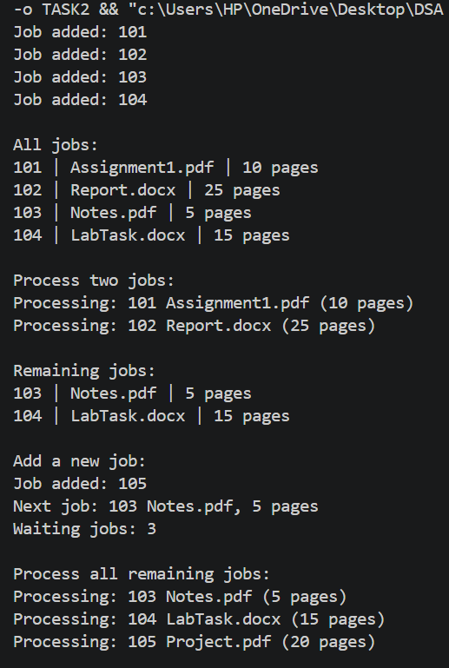
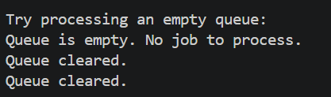

Task 3 - Infix to Postfix Conversion and Expression Evaluation
Implement a program that uses a stack to convert an arithmetic expression from infix notation to postfix notation and then evaluate the resulting postfix expression.
The expression should support:
- Addition +
- Subtraction -
- Multiplication *
- Division /
- Modulus %
- Parentheses ()
The program should support the following operations:
- Read Expression – Accept an arithmetic expression from the user.
- Check Operators – Identify operators and operands in the expression.
- Determine Precedence – Apply the correct precedence of arithmetic operators.
- Convert Infix to Postfix – Use a stack to produce the postfix expression.
- Display Postfix Expression – Display the converted expression.
- Evaluate Postfix Expression – Use a stack to calculate the final result.
- Handle Parentheses – Correctly process opening and closing parentheses.
- Clear Stack – Release all dynamically allocated stack nodes.
Implementation Requirements
- Implement the stack using linked nodes.
- Do not use the STL stack.
- Operators must be temporarily stored in the stack during conversion.
- Operands should be placed into the postfix expression in the appropriate order.
- Operator precedence must be respected.
- Parentheses must be handled correctly.
- During postfix evaluation, operands and intermediate results should be managed using a stack.
- Correctly handle expressions containing multiple operators.
- Detect mismatched parentheses.
- Detect division by zero.
- Handle invalid or empty expressions appropriately.
- All dynamically allocated nodes must be properly deleted.

CODE:

#include <iostream>
#include <string>
#include <sstream>
#include <cctype>
using namespace std;

template <class T>
struct Node {
T data;
Node<T>* next;

Node(T value) {
data = value;
next = NULL;
}
};

template <class T>
class Stack {
Node<T>* topNode;

public:
Stack() {
topNode = NULL;
}

bool isEmpty() {
return topNode == NULL;
}

void push(T value) {
Node<T>* n = new Node<T>(value);
n->next = topNode;
topNode = n;
}

bool pop(T& value) {
if (isEmpty())
return false;

Node<T>* temp = topNode;
value = temp->data;
topNode = topNode->next;
delete temp;
return true;
}

bool top(T& value) {
if (isEmpty())
return false;

value = topNode->data;
return true;
}

void clear() {
T value;
while (pop(value)) {}
}

~Stack() {
clear();
}
};

int precedence(char op) {
if (op == '*' || op == '/' || op == '%')
return 2;
if (op == '+' || op == '-')
return 1;
return 0;
}

bool isOperator(char c) {
return c == '+' || c == '-' || c == '*' ||
c == '/' || c == '%';
}

bool convert(string infix, string& postfix) {
Stack<char> ops;
postfix = "";
bool expectOperand = true;
bool hasToken = false;

for (int i = 0; i < (int)infix.size();) {
char c = infix[i];

if (isspace(c)) {
i++;
continue;
}

if (isdigit(c)) {
if (!expectOperand) {
cout << "Invalid expression.\n";
return false;
}

while (i < (int)infix.size() &&
isdigit(infix[i])) {
postfix += infix[i++];
}

postfix += ' ';
expectOperand = false;
hasToken = true;
}
else if (c == '(') {
if (!expectOperand) {
cout << "Invalid expression.\n";
return false;
}

ops.push(c);
i++;
}
else if (c == ')') {
if (expectOperand) {
cout << "Invalid expression.\n";
return false;
}

char op;
bool found = false;

while (ops.pop(op)) {
if (op == '(') {
found = true;
break;
}

postfix += op;
postfix += ' ';
}

if (!found) {
cout << "Mismatched parentheses.\n";
return false;
}

i++;
expectOperand = false;
}
else if (isOperator(c)) {
if (expectOperand) {
cout << "Invalid expression.\n";
return false;
}

char op;
while (ops.top(op) && op != '(' &&
precedence(op) >= precedence(c)) {
ops.pop(op);
postfix += op;
postfix += ' ';
}

ops.push(c);
i++;
expectOperand = true;
}
else {
cout << "Invalid character.\n";
return false;
}
}

if (!hasToken || expectOperand) {
cout << "Empty or invalid expression.\n";
return false;
}

char op;
while (ops.pop(op)) {
if (op == '(') {
cout << "Mismatched parentheses.\n";
return false;
}

postfix += op;
postfix += ' ';
}

return true;
}

bool evaluate(string postfix, long long& result) {
Stack<long long> values;
stringstream ss(postfix);
string token;

while (ss >> token) {
if (isdigit(token[0])) {
try {
size_t pos;
long long value = stoll(token, &pos);

if (pos != token.size())
return false;

values.push(value);
}
catch (...) {
cout << "Number out of range.\n";
return false;
}
}
else if (token.size() == 1 &&
isOperator(token[0])) {
long long b, a;

if (!values.pop(b) || !values.pop(a)) {
cout << "Invalid expression.\n";
return false;
}

long long answer;

switch (token[0]) {
case '+': answer = a + b; break;
case '-': answer = a - b; break;
case '*': answer = a * b; break;

case '/':
if (b == 0) {
cout << "Division by zero.\n";
return false;
}
answer = a / b;
break;

case '%':
if (b == 0) {
cout << "Modulus by zero.\n";
return false;
}
answer = a % b;
break;

default:
return false;
}

values.push(answer);
}
else {
cout << "Invalid postfix token.\n";
return false;
}
}

if (!values.pop(result) || !values.isEmpty()) {
cout << "Invalid expression.\n";
return false;
}

return true;
}

int main() {
string infix, postfix;
long long result;

cout << "Enter an infix expression: ";
getline(cin, infix);

if (convert(infix, postfix)) {
cout << "Postfix: " << postfix << endl;

if (evaluate(postfix, result))
cout << "Result: " << result << endl;
}

return 0;
}

Test Cases
Test the following expressions:

Test 1
2 + 3 * 4
Expected result:
14
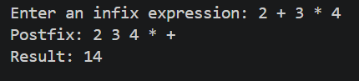

Test 2
(2 + 3) * 4
Expected result:
20
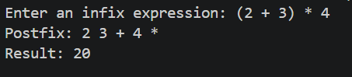

Test 3
10 + 2 * 6
Expected result:
22
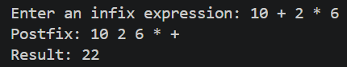

Test 4
(10 + 2) * (6 - 3)
Expected result:
36
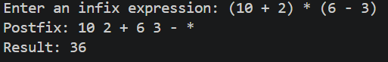

Test 5
20 / 5 + 3
Expected result:
7
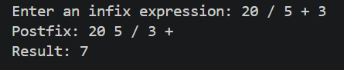

Also test:
- Nested parentheses
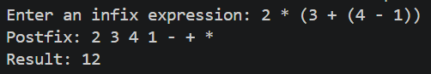
- Multiple operators
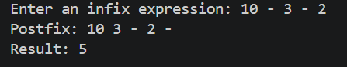
- Empty expression
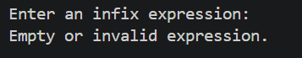
- Mismatched parentheses
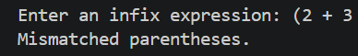
- Division by zero
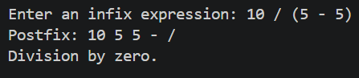

No. | Course Learning Outcomes (CLO) | PLO (SE) | SO (CS/DS/AI) | BT Level | Teaching & Learning Methods | Assessment Methods
CLO 1 | Describe the fundamentals of data structures and algorithms | NA | 2 | C-2 (Understand) | Active Learning, Blended Learning | Quiz, Assignment, MSE, ESE
CLO 2 | Solve a given real time problem by applying appropriate data structure and algorithm. | NA | 3 | C-3 (Apply) | Active Learning, Cooperative Learning, Blended Learning | Quiz, Assignment, Lab, MSE, ESE
CLO 3 | Practice programs using the latest IDEs ensuring testing, documentation and packaging of programs as per standards practices applicable to the software industry. | NA | 5 | P-3 (Guided Response) | Active Learning, Cooperative Learning, Blended Learning | Lab
CLO 4 | Demonstrate commitment to professional ethics by following engineering norms applicable to the software industry. | NA | 7 | A-3 (Valuing) | Active Learning, Cooperative Learning | Project, Lab
CLO 5 | Contribute effectively both individually and as a team member | NA | 6 | A-2 (Responding) | Active Learning, Cooperative Learning | Project, Lab

